Nama : Yusril

NIM : D0221523

Kelas : C

1. Tipe Data Primitif 1 Dimensi

public class Main {

public static void main(String[] args) {

// Mendefinisikan array dengan semua tipe data primitif

byte[] byteArray = {127, -128};

short[] shortArray = {32767, -32768};

int[] intArray = {2147483647, -2147483648};

long[] longArray = {9223372036854775807L, -9223372036854775808L};

float[] floatArray = {3.4028235E38f, 1.4E-45f};

double[] doubleArray = {1.7976931348623157E308, 4.9E-324};

char[] charArray = {'A', 'B'};

boolean[] booleanArray = {true, false};

// Menampilkan nilai dari setiap array

System.out.println("Nilai byteArray: " + byteArray[0] + ", " + byteArray[1]);

System.out.println("Nilai shortArray: " + shortArray[0] + ", " + shortArray[1]);

System.out.println("Nilai intArray: " + intArray[0] + ", " + intArray[1]);

System.out.println("Nilai longArray: " + longArray[0] + ", " + longArray[1]);

System.out.println("Nilai floatArray: " + floatArray[0] + ", " + floatArray[1]);

System.out.println("Nilai doubleArray: " + doubleArray[0] + ", " + doubleArray[1]);

System.out.println("Nilai charArray: " + charArray[0] + ", " + charArray[1]);

System.out.println("Nilai booleanArray: " + booleanArray[0] + ", " + booleanArray[1]);

}

}

Hasil Program :

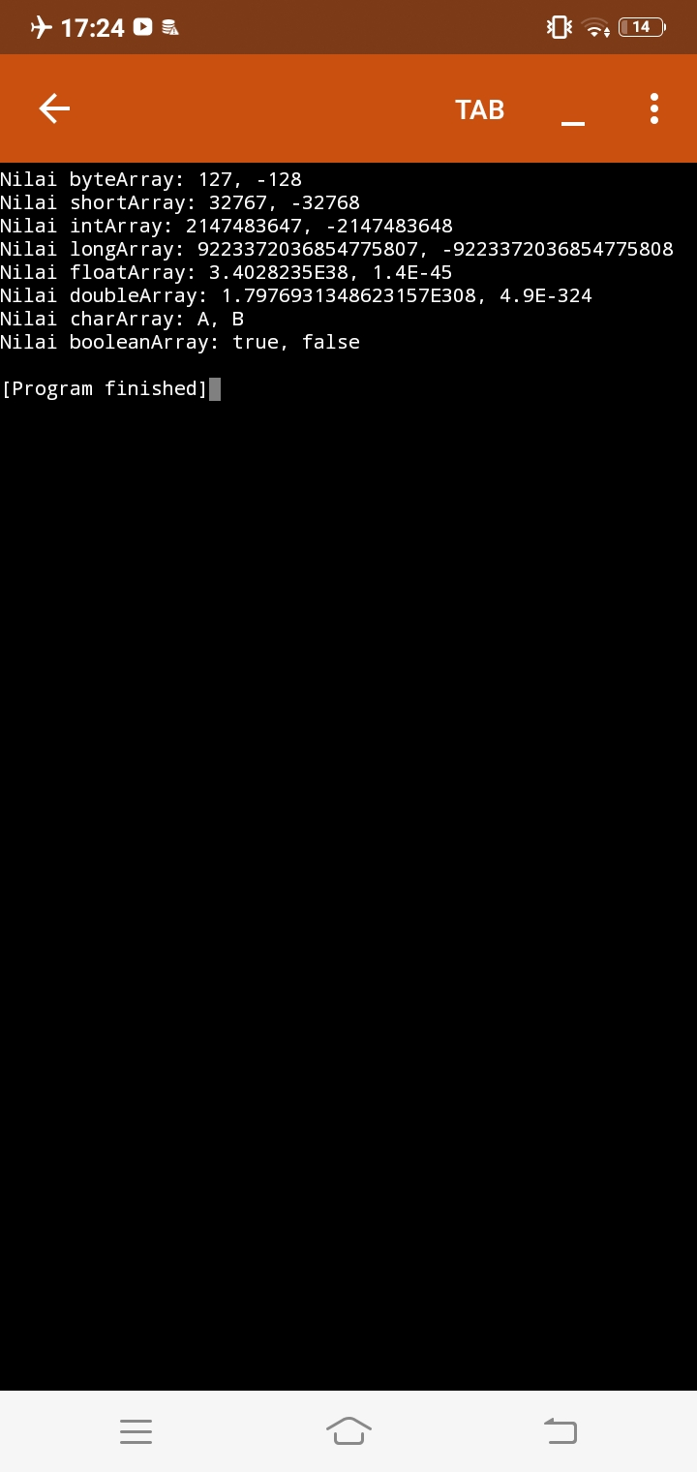

1. Tipe Data Primitif 2 Dimensi

public class PrimitiveTypesExample {

public static void main(String[] args) {

// Tipe primitif byte

byte[][] byteArray = {{1, 2}, {3, 4}};

System.out.println("Byte: " + byteArray[0][0] + ", " + byteArray[0][1]);

System.out.println("Byte: " + byteArray[1][0] + ", " + byteArray[1][1]);

// Tipe primitif short

short[][] shortArray = {{10, 20}, {30, 40}};

System.out.println("Short: " + shortArray[0][0] + ", " + shortArray[0][1]);

System.out.println("Short: " + shortArray[1][0] + ", " + shortArray[1][1]);

// Tipe primitif int

int[][] intArray = {{100, 200}, {300, 400}};

System.out.println("Int: " + intArray[0][0] + ", " + intArray[0][1]);

System.out.println("Int: " + intArray[1][0] + ", " + intArray[1][1]);

// Tipe primitif long

long[][] longArray = {{1000L, 2000L}, {3000L, 4000L}};

System.out.println("Long: " + longArray[0][0] + ", " + longArray[0][1]);

System.out.println("Long: " + longArray[1][0] + ", " + longArray[1][1]);

// Tipe primitif float

float[][] floatArray = {{3.14f, 6.28f}, {9.42f, 12.56f}};

System.out.println("Float: " + floatArray[0][0] + ", " + floatArray[0][1]);

System.out.println("Float: " + floatArray[1][0] + ", " + floatArray[1][1]);

// Tipe primitif double

double[][] doubleArray = {{3.14159, 6.28318}, {9.42477, 12.56636}};

System.out.println("Double: " + doubleArray[0][0] + ", " + doubleArray[0][1]);

System.out.println("Double: " + doubleArray[1][0] + ", " + doubleArray[1][1]);

// Tipe primitif boolean

boolean[][] booleanArray = {{true, false}, {false, true}};

System.out.println("Boolean: " + booleanArray[0][0] + ", " + booleanArray[0][1]);

System.out.println("Boolean: " + booleanArray[1][0] + ", " + booleanArray[1][1]);

// Tipe primitif char

char[][] charArray = {{'A', 'B'}, {'C', 'D'}};

System.out.println("Char: " + charArray[0][0] + ", " + charArray[0][1]);

System.out.println("Char: " + charArray[1][0] + ", " + charArray[1][1]);

}

}

Hasil Program :

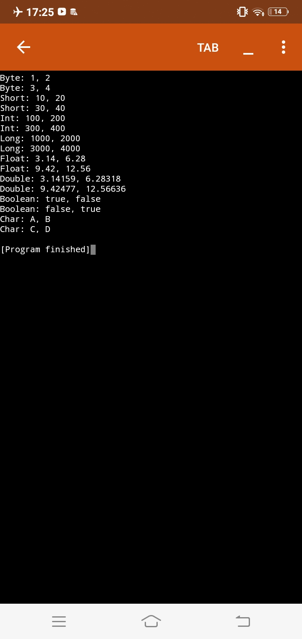

1. Tipe Data Non Primitif

import java.util.ArrayList;

import java.util.HashMap;

public class NonPrimitiveTypesExample {

public static void main(String[] args) {

// Tipe data array

int[] intArray = {1, 2, 3, 4, 5};

System.out.println("Array:");

for (int num : intArray) {

System.out.print(num + " ");

}

System.out.println();

// Tipe data ArrayList

ArrayList<String> stringList = new ArrayList<>();

stringList.add("Apple");

stringList.add("Banana");

stringList.add("Orange");

System.out.println("ArrayList:");

for (String fruit : stringList) {

System.out.println(fruit);

}

// Tipe data HashMap

HashMap<String, Integer> studentScores = new HashMap<>();

studentScores.put("John", 95);

studentScores.put("Alice", 87);

studentScores.put("Bob", 92);

System.out.println("HashMap:");

for (String name : studentScores.keySet()) {

System.out.println(name + ": " + studentScores.get(name));

}

}

}

Hasil Program :

